Keep the Music Playing
FREE Event for Strongsville High School Band Students
Wednesday, May 15 -- 5:00 to 7:30pm – Royalton Music Center
Out of concern for any learning, practicing, and joy of playing that may have been lost due to the Strongsville Teachers’ Strike, a local non-profit organization, The Roberto Ocasio Foundation, and Royalton Music Center are sponsoring and hosting an evening get together for Strongsville High School Band students “to keep the music playing.”
Come and have fun playing along with some quick study—learn new material or refresh some familiar tunes with an energetic New York attitude and Latin perspective. The Foundation’s Artistic Director and Artist-In-Residence, Bobby Sanabria, will be coming from NYC’s Manhattan School of Music and New School University to teach and lead the ensemble. A renowned performer, educator, band leader, composer, and arranger, he is also a seven-time Grammy®- nominated recording artist and award-winning documentary producer for PBS and the Smithsonian. (bobbysanabria.com)
There is no charge for this event, but registration is needed by May 8th. Please contact Bev Montie with the Foundation (440.572.2048 or trof@robertoocasiofoundation.org) or Royalton Music Center (440.237.9400) with your information: name, address, phone number, e-mail address, and instrument. Students are required to bring their own instruments and music stands.
THE 2013 ROBERTO OCASIO LATIN JAZZ MUSIC CAMP
For Music Students, Grades 8-12 (incl 2013 grads)
July 7-12 – Cleveland State University
Bobby Sanabria, Artistic Director/Artist-In-Residence
A resident camp; tuition covers all (dorm room, meals, instruction, materials, field trips, activities, FREE Public Recital Concert). ENROLL on May 15 at Royalton Music and receive a $100 discount off the $575 tuition.
robertoocasiofoundation.org.
Registration limited to the first 30 students (names put on waiting list thereafter).

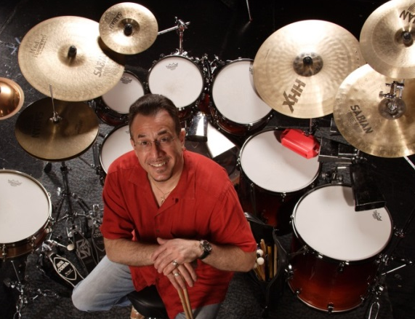
Setup at 5pm (earlier if you can make it) and the session will start promptly at 5:30pm. Open audience seating 6:30-7:30pm with a 50 guest capacity.

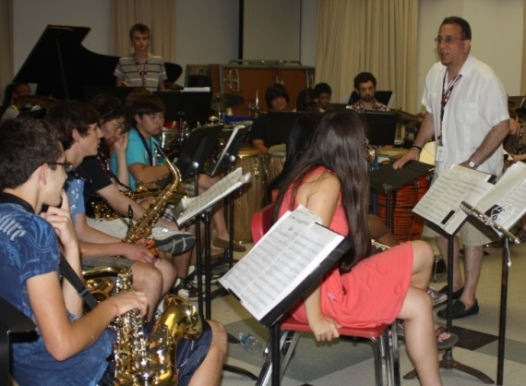
See you at:
Royalton Music Center
10167 Royalton Road
North Royalton, OH 44133

